**Rovers Floating Launcher**

Change the way you use your device. Do it better.

**‘Rovers Floating Launcher’ is now available for free on** [**Google Play**](https://play.google.com/store/apps/details?id=com.schiztech.rovers.app)

**Rovers will always be there for you, to create the PERFECT multitask utility on Android.**

Imagine you could go to any of your favorite apps with a single click, from anywhere, whether you’re currently playing Candy Crush or checking the news online.

That’s Rovers, always there for you, above any other app, waiting for your call. You’ll always be just one-click away from your favorite apps, shortcuts and actions.

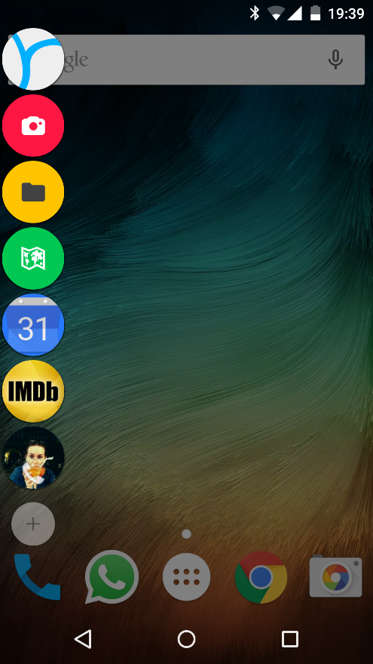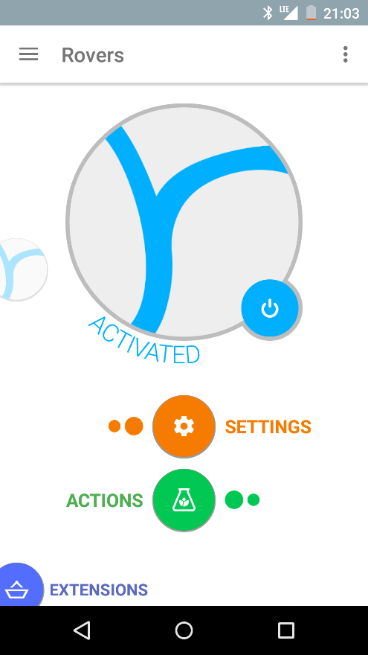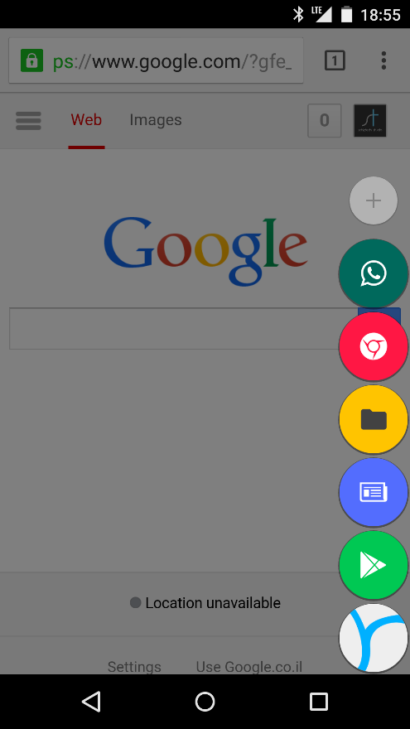

Rovers was designed to match the main Android style guidelines in order to blend in perfectly, as if it was a part of your Android experience all along.

Rovers has many customization options that allow you to make your Rovers experience unique, with thousands of possible colors & icons combinations for each Rover item.

Rovers was developed by SchizTech Studio, proud developers of [Swapps](https://play.google.com/store/apps/details?id=com.schiztech.swapps) & [Snapy](https://play.google.com/store/apps/details?id=com.schiztech.snapy) applications.

###

For any assistance, press & interview inquiries please contact:

Dor Yehuda, SchizTech [dor@schiztech.com](mailto:dor@schiztech.com) | (+1) 914 3364890

Rovers on Google Play: <https://play.google.com/store/apps/details?id=com.schiztech.rovers.app>

Rovers Press Kit: <https://goo.gl/QHhMtJ>

Rovers Website: <https://schiztech.com/app/rovers>

SchizTech Studio Website: <https://schiztech.com>

SchizTech Studio on Twitter: <https://twitter.com/SchizTech>